EXECUTIVE SUMMARY: Data Integrity and Master Dataset Consolidation
To: Strategy / Operations Leadership
From: Strategic Data Analysis Team
Subject: Validation and Readiness of Master Dataset v1.0

1. Strategic Recommendation (The Bottom Line)
It is recommended to approve Master Dataset v1.0 as the single source of truth for predictive modeling and strategic decision-making. Following a rigorous audit process, the dataset has reached "Production Level" status, ensuring that campaign investment decisions are based on precise technical data rather than assumptions.

2. Business Case (Why trust these data)
- Certified Total Coverage: 3,220 county records have been consolidated, covering 100% of the US electoral geography. Without this integrity, any regional analysis would be partial and biased.
- Elimination of Identification Errors: FIPS code normalization (standardized to 5 digits) allows for seamless integration with heatmaps and third-party geolocation tools.
- Risk Mitigation (Sanity Check): The logical relationship between total population and cast ballots has been verified, eliminating anomalies that could have inflated or distorted victory margins.

3. Evidence of Quality Process

A. Critical Variable Dictionary
Variable | Cleaning Action | Business Impact
county_fips | Z-fill (5 digits) | Enables error-free geolocation.
Votes (DEM/REP) | Validation vs TotalPop | Ensures calculated margins are real.
Demographics (%) | Null Treatment | Ensures precision in multi-ethnic analysis.

4. Roadmap (Next Steps)
With the validated database, the team proceeds immediately to the Competitiveness Phase (Day 2), focusing on detecting the 156 breaking points (Swing Counties) that will determine the success of the electoral strategy.
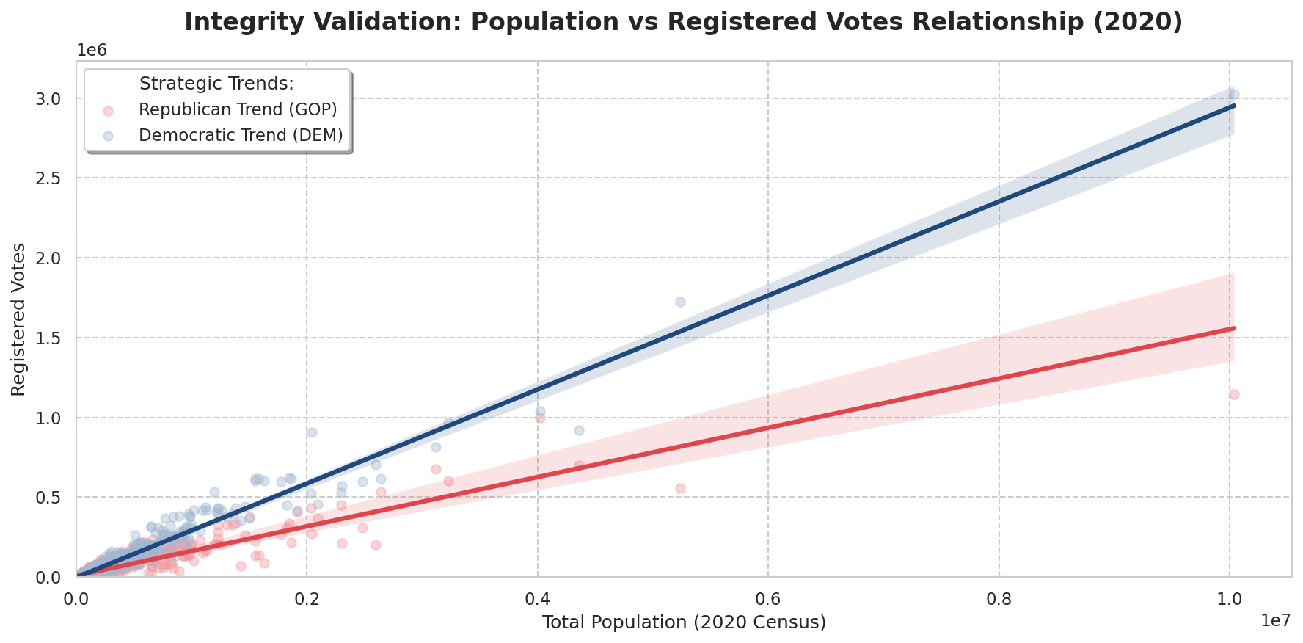
Technical Validation Document | Strategic Data Partner Methodology | v1.0 (Day 1)

